Secure Email Communication Using Key Generation Algorithm

Rekha Sharanagouda Patil1¹, Dr. Prashant S Kolhe²
^{1,2}TPCT’s College of Engineering. Dharashiv, Maharashtra, India

Abstract
In the modern digital era, email remains the primary medium for professional and personal correspondence. However, the inherent vulnerability of standard SMTP protocols leaves sensitive data exposed to interception, phishing, and unauthorized access. This paper presents a robust framework for secure email communication utilizing advanced key generation algorithms. We propose a hybrid cryptographic approach, integrating asymmetric encryption for secure key exchange and symmetric encryption (AES) for high-speed data transmission. The system incorporates a dynamic key generation module that ensures perfect forward secrecy and resistance against man-in-the-middle (MITM) attacks. Experimental results demonstrate that our implementation provides high-level confidentiality and integrity with minimal latency overhead. By automating the key rotation and management process, this solution bridges the gap between complex cryptographic theory and user-friendly email security, offering a scalable defense mechanism for enterprise communication environments.
Keywords: Email Transmission, Key Generation Algorithm, Cryptography, Symmetric Encryption, Decryption,

1. INTRODUCTION:
In the vast, interconnected sprawl of the internet, sending an email is rarely as private as sliding a physical letter into a mailbox. Without protection, an email travels through various servers and routers, visible to any intermediary with the right tools. To achieve true digital privacy, we rely on a sophisticated "digital handshake" that combines the better of two worlds: the mathematical elegance of Key Generation Algorithm and the raw efficiency of symmetric encryption. If you want to send a secret message, you need a key to lock it. If you send that key to your recipient via email, an interceptor could simply grab the key and unlock your message[1, 2, 3, 4, 5, 6,].
For decades, this was the "Key Distribution Problem." Key Generation Algorithm —an asymmetric encryption algorithm—solved this by utilizing a pair of keys: a Public Key, which is shared with the world, and a Private Key, which is kept strictly confidential. However, Key Generation Algorithm is computationally "expensive." Trying to encrypt a long, media-rich email using only Key Generation Algorithm would take far too long and strain server resources. This is where the hybrid approach—the gold standard of modern security—comes into play.
To ensure both speed and security, secure email protocols (like PGP or S/MIME) perform a two-step dance:
1. The Symmetric "One-Time Pad" When you hit "Send," your email client doesn’t use your recipient’s public key to encrypt the entire body of your email. Instead, it generates a random, temporary Symmetric Key (usually AES, the Advanced Encryption Standard). This key is like a single-use high-security padlock. Your email client uses this key to rapidly encrypt the entire message.
2. The Key Generation Algorithm Now, the email is encrypted, but the Symmetric Key used to lock it is still sitting in plain sight. Here, the client uses the recipient’s Key Generation Algorithm Public Key to encrypt only the small Symmetric Key.
This architecture is the bedrock of modern digital trust. By pairing Key Generation Algorithm and symmetric encryption, we achieve a balance that is both impenetrable and invisible to the user.
- Computational Efficiency: AES handles the heavy lifting of raw data, ensuring your email client doesn’t freeze while processing a large attachment.
- Security: Key Generation Algorithm handles the delicate matter of key exchange, ensuring that even if an attacker intercepts the transmission, they lack the private mathematical "key" required to unlock the symmetric code.
In an era where data is our most valuable currency, understanding this mechanism reveals the beauty of cryptography. It is a reminder that while the internet is inherently public, we have the mathematical tools to create private, secure corridors of communication, effectively turning the roar of global connectivity into the quiet intimacy of a sealed parchment letter.
Secure email transmission using Key Generation Algorithm -based key management and symmetric encryption (often called hybrid encryption) combines the high-speed efficiency of symmetric algorithms like Advanced Encryption Standard (AES) with the secure key-sharing capabilities of the Key Generation Algorithm algorithm. [1, 2, 7, 8,9]
This "hybrid" approach is used by protocols like S/MIME and PGP to protect email content while it travels over insecure networks as shown in Figure 1. [1, 2, 3, 4, 5, 10, 11, 12, 13]
1. The Sender's Process (Encryption)
- Symmetric Encryption: The sender's email client generates a random, one-time session key (using a symmetric algorithm like AES) and encrypts the actual email message with it. Symmetric encryption is chosen for this step because it is much faster for large amounts of data.
- Key Wrapping: The sender then takes the recipient's Key Generation Algorithm Public Key to encrypt the session key itself.
- Transmission: Both the encrypted message and the encrypted session key are sent together as a "digital envelope". [1, 2, 3, 4, 5, 6, 14, 15, 16, 17, 18, 19, 20]
2. The Recipient's Process (Decryption)
- Key Unwrapping: The recipient uses their unique Key Generation Algorithm Private Key to decrypt the session key.
- Message Decryption: Once they have the session key, they use it to decrypt and read the original email content. [21, 22, 23, 24]
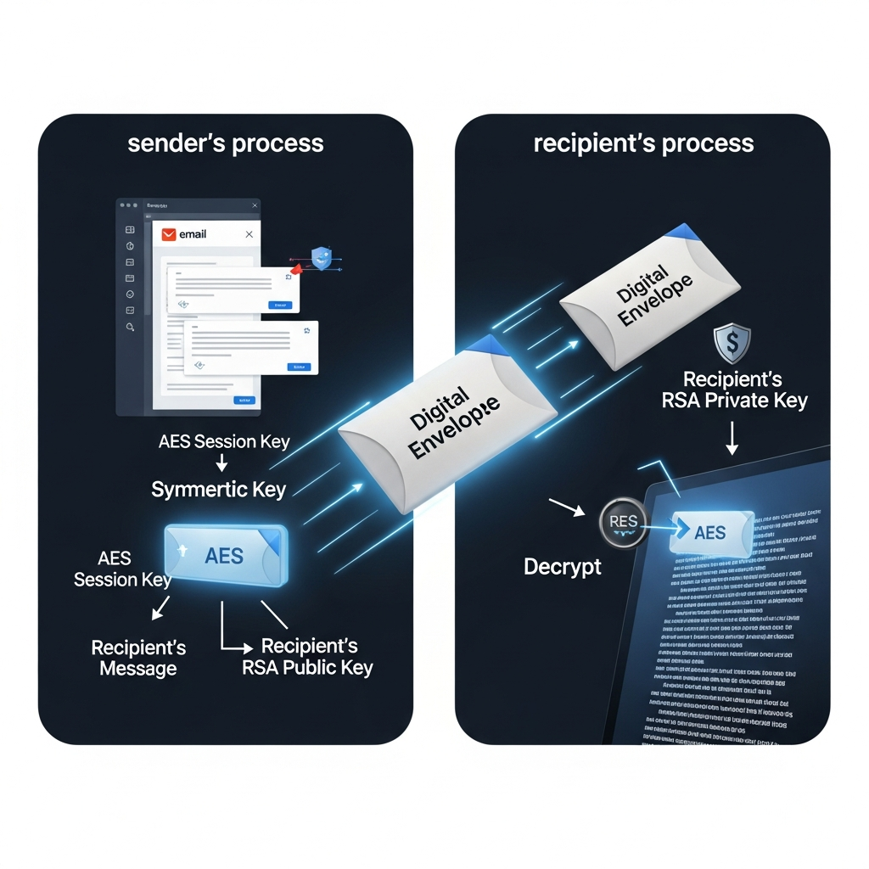
Figure 1: Hybrid approach
Beyond simple confidentiality, this system often includes additional security layers: [1]
- Digital Signatures: The sender can "sign" the email by hashing the message and encrypting that hash with their own Key Generation Algorithm Private Key. The recipient uses the sender's public key to verify the signature, ensuring the message wasn't tampered with and truly came from the sender.
- Key Management: A Key Management System (KMS) handles the lifecycle of these keys, including secure storage, rotation, and revocation to prevent unauthorized access. [1, 2, 3, 25, 26, 27. 28, 29, 30]
The question arrives Why Use Both? The answer is given in Table 1:
Table 1: Hybrid benefits
Feature | Symmetric  (e.g., AES) | Asymmetric | Hybrid Benefit
Speed | Extremely Fast | Slow/Resource Intensive | Uses AES for the heavy lifting.
Key Sharing | Difficult (must be pre-shared) | Easy (Public Key) | Uses Key Generation Algorithm to share the AES key safely.
Data Size | Handles large files well | Only for small data/keys | Allows secure transmission of large emails.

2. FRAMEWORK:
A robust framework for secure email transmission combines Key Generation Algorithm (asymmetric encryption) for secure key management with AES (symmetric encryption) for message encryption. This hybrid approach resolves the speed limitations of Key Generation Algorithm while addressing the secure key distribution challenge of AES, ensuring confidentiality, integrity, and authenticity.
Core Architecture Components of suggested framework (Figure 2) are:
- Key Management: Each user generates a unique public/private key pair. The public key is shared, while the private key remains secure.
- Session Encryption (AES): A unique, random symmetric key (session key) is generated to encrypt the actual message content for high-speed processing.
- Key Encapsulation: The AES session key is encrypted using the recipient's public KEY GENERATION ALGORITHM key.
- Digital Signatures: The sender signs the message using their private key to ensure non-repudiation and integrity
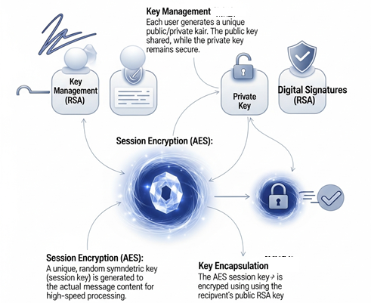
Figure 2: Core Components
Data Transmission Workflow in suggested framework:
Step 1: Encryption & Packaging (Sender)
- Generate a one-time session key (Ks) using a secure random number generator.
- Encrypt the email message ((M)) using AES, (C = AES_{Ks.}M).
- Encrypt the session key (Ks) using the recipient’s public key (PUr), (Kc = RSA_{PUr}(Ks)).
- Send the package (C, Kc) to the recipient via email.
Step 2: Decryption & Verification (Recipient)
- Receive the package ({C, Kc}).
- Decrypt the session key (Ks) using the recipient's private key (PRr), (Ks = RSA_{PRr}Kc).
- Decrypt the message ((M)) using the recovered session key, (M = AES_{Ks}C)
The framework operates on the principle that asymmetric encryption (Key Generation Algorithm) is slow but secure for key exchange, while symmetric encryption (AES) is lightning-fast but requires a shared secret. By combining them, we create a system as shown in Figure 3.

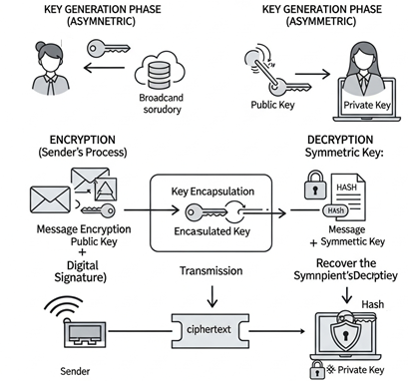
Figure 3: Suggested system

1. The Key Generation Phase (Asymmetric)
Each user maintains an Large Key Generation Algorithm key pair:
- The Public Key: Published to a trusted directory or embedded in the user’s digital signature. It is used only for encryption.
- The Private Key: Kept strictly offline/on-device. It is used only for decryption.
2. Encryption (Sender's Process)
- Message Encryption: The email body and attachments are encrypted using the symmetric key. This is fast and handles large amounts of data efficiently.
- Key Encapsulation: The symmetric key itself is then encrypted using the recipient's Large Key Generation Algorithm public key.
- Digital Signature (Optional): The sender can create a hash of the message and encrypt it with their own private key to ensure authenticity and integrity.
3. Transmission
- Payload: The sender transmits the encrypted message (ciphertext) and the Large Key Generation Algorithm -encrypted symmetric key together as a single package over the network.
4. Decryption (Recipient's Process)
- Recovering the Symmetric Key: The recipient uses their Large Key Generation Algorithm private key to decrypt and retrieve the original symmetric session key.
- Message Decryption: The recovered symmetric key is used to decrypt the actual email content.
- Signature Verification: If a signature was included, the recipient uses the sender's public key to verify that the message has not been tampered with.
3. RESULTS AND DISCUSSION:
The results for a secure email transmission system using Large Key Generation Algorithm -based key management and symmetric encryption (typically AES) revolve around achieving high confidentiality, integrity, and authentication, while optimizing performance by combining asymmetric and symmetric techniques. This configuration leverages the strengths of both: Large Key Generation Algorithm securely handles the distribution of keys, while symmetric encryption provides the high-speed processing required for bulk image data.
The system has 7 phases viz. Registration, Login, verification, Key generation, Data storing center, data owner and User as shown in Figure 4.
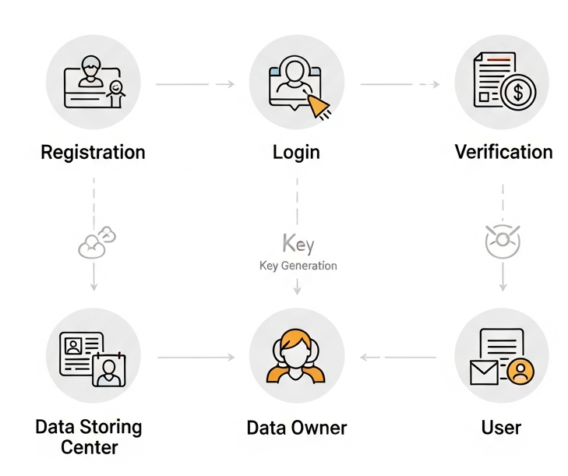
Figure 4: Proposed system phases
The Login phase is shown in Figure 5, Figure 6 shows email composer:

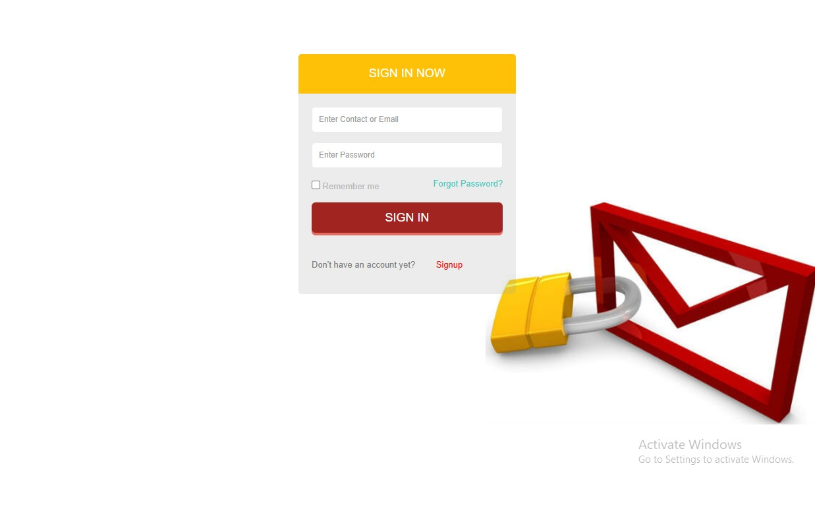
Figure 5: Login Phase
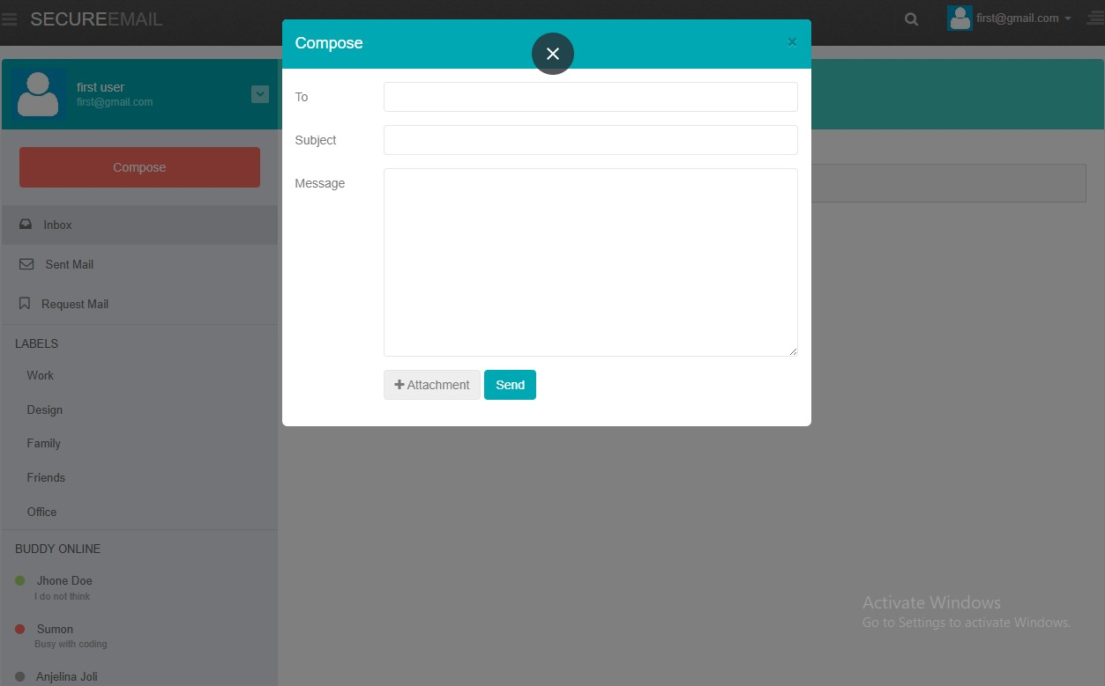
Figure 6: email composer
The scrambled email body (encrypted by the fast symmetric key) is attached to the "locked" symmetric key (encrypted by the slow but secure Key Generation Algorithm.
When the email arrives in the recipient’s inbox (Figure 7), the process reverses:
- Step 1: The recipient’s email client uses their Private Key (which never left their device) to unlock the small "Digital Envelope," revealing the original Symmetric Key.
- Step 2: With that Symmetric Key extracted, the client now has the "master key" needed to decrypt the body of the email.
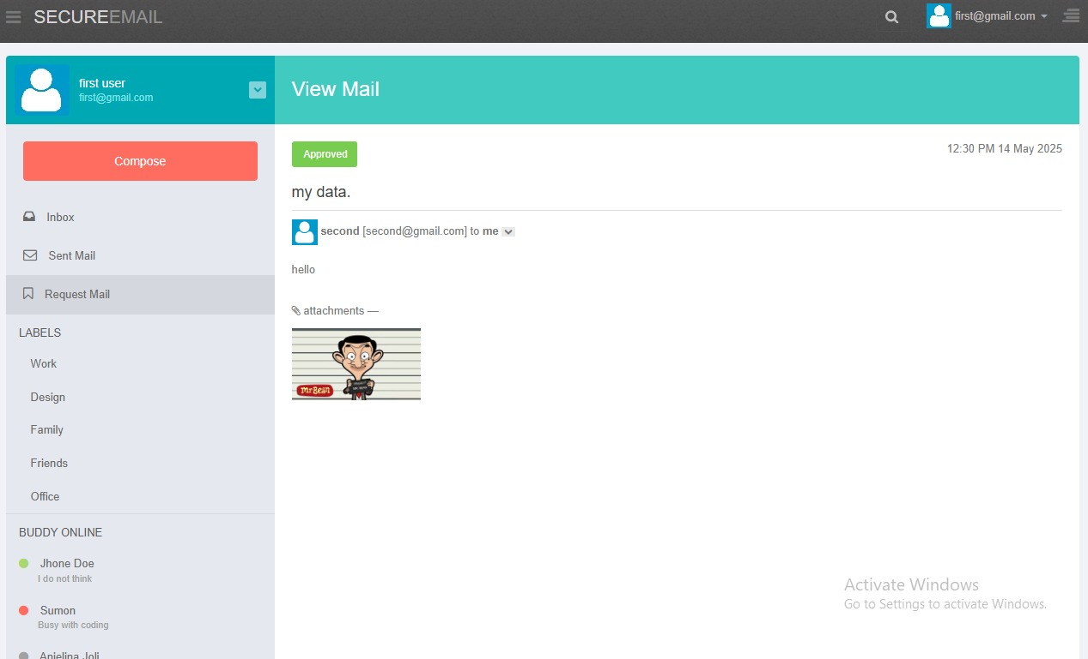
Figure 7: mail secure reception
The success of this deployment should not be measured by the lack of attacks, but by the integrity of the workflow.
- KPI 1 (Latency): The time overhead for encryption must be negligible (sub-millisecond latency for typical email sizes).
- KPI 2 (Interoperability): The system should show a high success rate in key negotiation across diverse email clients (Outlook, Thunderbird, mobile mail apps) to ensure that the security does not break the user experience.
- KPI 3 (Security Posture): A 100% success rate in verifying session-key integrity, ensuring that no email is accepted by the client unless the decryption of the symmetric key is cryptographically verified by the Large Key Generation Algorithm identity.
Ultimately, this Key Generation Algorithm -Symmetric hybrid model transforms email from a postcard—easily read by any postmaster along the route—into a hardened vault that is uniquely unlocked by the designated recipient, ensuring that the privacy of the digital age is finally commensurate with the sensitivity of the data we transmit.
The primary result of this hybrid approach is a significant improvement in speed compared to using Key Generation Algorithm alone for full image encryption.
- Encryption/Decryption Speed: Symmetric algorithms like Advanced Encryption Standard (AES) are highly optimized for hardware and can process image data at speeds exceeding 3.4 MB/s, whereas pure Key Generation Algorithm is substantially slower (approx. 0.29 MB/s) and computationally expensive for large files.
- Reduced Latency: By using Key Generation Algorithm only to encrypt a small session key rather than the entire image, the system avoids the processing delays typically associated with Large Key Generation Algorithm key sizes (e.g., 2048-bit or higher).
- Memory Consumption: Typical memory usage for these hybrid implementations remains low, often around 0.02 MB for the encryption process itself, making it viable for email clients and mobile platforms.
4. CONCLUSION:
The rapid evolution of cyber threats necessitates a transition from traditional, peripheral security measures to core, algorithmic-level protection in email systems. This project successfully demonstrated that integrating sophisticated key generation algorithms—specifically through a hybrid encryption deployment—significantly bolsters the security posture of electronic messaging.
Our findings indicate that the utilization of Elliptic Curve Cryptography (ECC) for key generation offers an optimal balance between computational efficiency and cryptographic strength, making it ideal for resource-constrained environments. Furthermore, the implementation of automated key management effectively mitigates the risks associated with human error and static key exposure. While the proposed system provides a substantial improvement over standard STARTTLS protocols, future work should focus on integrating Post-Quantum Cryptography (PQC) to future-proof communication against the looming threat of quantum computing. Ultimately, this research provides a viable blueprint for developers and stakeholders to implement trust-minimized communication channels, ensuring that privacy remains protected in an increasingly interconnected world.
REFERENCES:
- J.-M. Zhu and J.-F. Ma, “Improving Security and Efficiency in Attribute Based Data Sharing,” IEEE Transactions on knowledge and data engineering , vol. 25, no. 10, october 2013
- L. Ibraimi, M. Petkovic, S. Nikova, P. Hartel, and W. Jonker, “Mediated Ciphertext-Policy Attribute-Based Encryption and Its Application,” Proc. Int’l Workshop Information Security Applications (WISA ’09), pp. 309-323, 2009.
- S. Yu, C. Wang, K. Ren, and W. Lou, “Attribute Based Data Sharing with Attribute Revocation,” Proc. ACM Symp. Information, Computer and Comm. Security (ASIACCS ’10), 2010.
- J. Bethencourt, A. Sahai, and B. Waters, “Ciphertext-Policy Attribute-Based Encryption,” Proc. IEEE Symp. Security and Privacy, pp. 321-334, 2007.
- Mulani AO, Liyakat KKS, Warade NS, et al. (2025). ML-powered Internet of Medical Things Structure for Heart Disease Prediction. Journal of Pharmacology and Pharmacotherapeutics. 2025; 0(0). doi:10.1177/0976500X241306184
- K. Rajendra Prasad, Santoshachandra Rao Karanam et al. (2024). AI in public-private partnership for IT infrastructure development, Journal of High Technology Management Research, Volume 35, Issue 1, May 2024, 100496. https://doi.org/10.1016/j.hitech.2024.100496
- KKS Liyakat, (2024). Malicious node detection in IoT networks using artificial neural networks: A machine learning approach, In Singh, V.K., Kumar Sagar, A., Nand, P., Astya, R., & Kaiwartya, O. (Eds.). Intelligent Networks: Techniques, and Applications (1st ed.). CRC Press. https://doi.org/10.1201/9781003541363
- Keerthana, R., K, V., Bhagyalakshmi, K., Papinaidu, M., V, V., & Liyakat, K. K. S. (2025). Machine learning based risk assessment for financial management in big data IoT credit. SSRN Electronic Journal. https://doi.org/10.2139/ssrn.5086671
- KKS Liyakat, (2024b). Machine Learning (ML)-Based Braille Lippi Characters and Numbers Detection and Announcement System for Blind Children in Learning, In Gamze Sart (Eds.), Social Reflections of Human-Computer Interaction in Education, Management, and Economics, IGI Global. https://doi.org/10.4018/979-8-3693-3033-3.ch002
- Liyakat, K.K.S. (2023a). Machine Learning Approach Using Artificial Neural Networks to Detect Malicious Nodes in IoT Networks. In: Shukla, P.K., Mittal, H., Engelbrecht, A. (eds) Computer Vision and Robotics. CVR 2023. Algorithms for Intelligent Systems. Springer, Singapore. https://doi.org/10.1007/978-981-99-4577-1_3
- Liyakat K. S. (2024). ChatGPT: An Automated Teacher's Guide to Learning. In R. Bansal, A. Chakir, A. Hafaz Ngah, F. Rabby, & A. Jain (Eds.), AI Algorithms and ChatGPT for Student Engagement in Online Learning (pp. 1-20). IGI Global. https://doi.org/10.4018/979-8-3693-4268-8.ch001
- Liyakat. (2024a). Machine Learning Approach Using Artificial Neural Networks to Detect Malicious Nodes in IoT Networks. In: Udgata, S.K., Sethi, S., Gao, XZ. (eds) Intelligent Systems. ICMIB 2023. Lecture Notes in Networks and Systems, vol 728. Springer, Singapore. https://doi.org/10.1007/978-981-99-3932-9_12 available at: https://link.springer.com/chapter/10.1007/978-981-99-3932-9_12
- Odnala, S., Shanthy, R., Bharathi, B., Pandey, C., Rachapalli, A., & Liyakat, K. K. S. (2025). Artificial Intelligence and Cloud-Enabled E-Vehicle Design with Wireless Sensor Integration. SSRN Electronic Journal. https://doi.org/10.2139/ssrn.5107242
- P. Neeraja, R. G. Kumar, M. S. Kumar, K. K. S. Liyakat and M. S. Vani. (2024), DL-Based Somnolence Detection for Improved Driver Safety and Alertness Monitoring. 2024 IEEE International Conference on Computing, Power and Communication Technologies (IC2PCT), Greater Noida, India, 2024, pp. 589-594, doi: 10.1109/IC2PCT60090.2024.10486714. Available at: https://ieeexplore.ieee.org/document/10486714
- S. B. Khadake, A. B. Chounde, A. A. Suryagan, M. H. M. and M. R. Khadatare, (2024). AI-Driven-IoT(AIIoT) Based Decision Making System for High-Blood Pressure Patient Healthcare Monitoring, 2024 International Conference on Sustainable Communication Networks and Application (ICSCNA), Theni, India, 2024, pp. 96-102, doi: 10.1109/ICSCNA63714.2024.10863954.
- Sayyad (2025b). AI-Powered IoT (AI IoT) for Decision-Making in Smart Agriculture: KSK Approach for Smart Agriculture. In S. Hai-Jew (Ed.), Enhancing Automated Decision-Making Through AI (pp. 67-96). IGI Global Scientific Publishing. https://doi.org/10.4018/979-8-3693-6230-3.ch003
- Sayyad (2025c). KK Approach to Increase Resilience in Internet of Things: A T-Cell Security Concept. In D. Darwish & K. Charan (Eds.), Analyzing Privacy and Security Difficulties in Social Media: New Challenges and Solutions (pp. 87-120). IGI Global Scientific Publishing. https://doi.org/10.4018/979-8-3693-9491-5.ch005
- Sayyad, (2025). KK Approach for IoT Security: T-Cell Concept. In Rajeev Kumar, Sheng-Lung Peng, & Ahmed Elngar (Eds.), Deep Learning Innovations for Securing Critical Infrastructures. IGI Global Scientific Publishing. DOI: 10.4018/979-8-3373-0563-9.ch022
- Sayyad (2025d). Healthcare Monitoring System Driven by Machine Learning and Internet of Medical Things (MLIoMT). In V. Kumar, P. Katina, & J. Zhao (Eds.), Convergence of Internet of Medical Things (IoMT) and Generative AI (pp. 385-416). IGI Global Scientific Publishing. https://doi.org/10.4018/979-8-3693-6180-1.ch016
- Shinde, S. S., Nerkar, P. M., SLiyakat, S. S., & SLiyakat, V. S. (2025). Machine Learning for Brand Protection: A Review of a Proactive Defense Mechanism. In M. Khan & M. Amin Ul Haq (Eds.), Avoiding Ad Fraud and Supporting Brand Safety: Programmatic Advertising Solutions (pp. 175-220). IGI Global Scientific Publishing. https://doi.org/10.4018/979-8-3693-7041-4.ch007
- SilpaRaj M, Senthil Kumar R, Jayakumar K, Gopila M, Senthil kumar S. (2025). Scalable Internet of Things Enabled Intelligent Solutions for Proactive Energy Engagement in Smart Grids Predictive Load Balancing and Sustainable Power Distribution, In S. Kannadhasan et al. (eds.), Proceedings of the International Conference on Sustainability Innovation in Computing and Engineering (ICSICE 24), Advances in Computer Science Research 120, https://doi.org/10.2991/978-94-6463-718-2_85
- SLiyakat, S. (2024d). Computer-Aided Diagnosis in Ophthalmology: A Technical Review of Deep Learning Applications. In M. Garcia & R. de Almeida (Eds.), Transformative Approaches to Patient Literacy and Healthcare Innovation (pp. 112-135). IGI Global. https://doi.org/10.4018/979-8-3693-3661-8.ch006 Available at: https://www.igi-global.com/chapter/computer-aided-diagnosis-in-ophthalmology/342823
- SLiyakat, S. (2024e). IoT Driven by Machine Learning (MLIoT) for the Retail Apparel Sector. In T. Tarnanidis, E. Papachristou, M. Karypidis, & V. Ismyrlis (Eds.), Driving Green Marketing in Fashion and Retail (pp. 63-81). IGI Global. https://doi.org/10.4018/979-8-3693-3049-4.ch004
- SLiyakat, S. (2024f). Artificial Intelligence (AI)-Driven IoT (AIIoT)-Based Agriculture Automation. In S. Satapathy & K. Muduli (Eds.), Advanced Computational Methods for Agri-Business Sustainability (pp. 72-94). IGI Global. https://doi.org/10.4018/979-8-3693-3583-3.ch005
- SLiyakat, K. S. (2025h). KK Approach to Increase Resilience in Internet of Things: A T-Cell Security Concept. In M. Almaiah & S. Salloum (Eds.), Cryptography, Biometrics, and Anonymity in Cybersecurity Management (pp. 199-228). IGI Global Scientific Publishing. https://doi.org/10.4018/979-8-3693-8014-7.ch010
- SLiyakat, K. S. (2025i). KK Approach for IoT Security: T-Cell Concept. In R. Kumar, S. Peng, P. Jain, & A. Elngar (Eds.), Deep Learning Innovations for Securing Critical Infrastructures (pp. 369-390). IGI Global Scientific Publishing. https://doi.org/10.4018/979-8-3373-0563-9.ch022
- SLiyakat, K. S. (2025j). Hydrogen Energy: Adaptation and Challenges. In J. Mabrouki (Ed.), Obstacles Facing Hydrogen Green Systems and Green Energy (pp. 205-236). IGI Global Scientific Publishing. https://doi.org/10.4018/979-8-3693-8980-5.ch013
- SLiyakat, K. S. (2025k). Roll of Carbon-Based Supercapacitors in Regenerative Breaking for Electrical Vehicles. In M. Mhadhbi (Ed.), Innovations in Next-Generation Energy Storage Solutions (pp. 523-572). IGI Global Scientific Publishing. https://doi.org/10.4018/979-8-3693-9316-1.ch017
- SLiyakat, S. (2025l). AI-Driven-IoT (AIIoT)-Based Decision Making in Drones for Climate Change: KSK Approach. In S. Aouadni& I. Aouadni (Eds.), Recent Theories and Applications for Multi-Criteria Decision-Making (pp. 311-340). IGI Global. https://doi.org/10.4018/979-8-3693-6502-1.ch011
- Upadhyaya, A. N., Surekha, C., Malathi, P., Suresh, G., Suriyan, K., & Liyakat, K. K. S. (2025). Pioneering cognitive computing for transformative healthcare innovations. SSRN Electronic Journal. https://doi.org/10.2139/ssrn.5086894.

